Industrial Mini PC
QY-B5400
Full IP66 Series

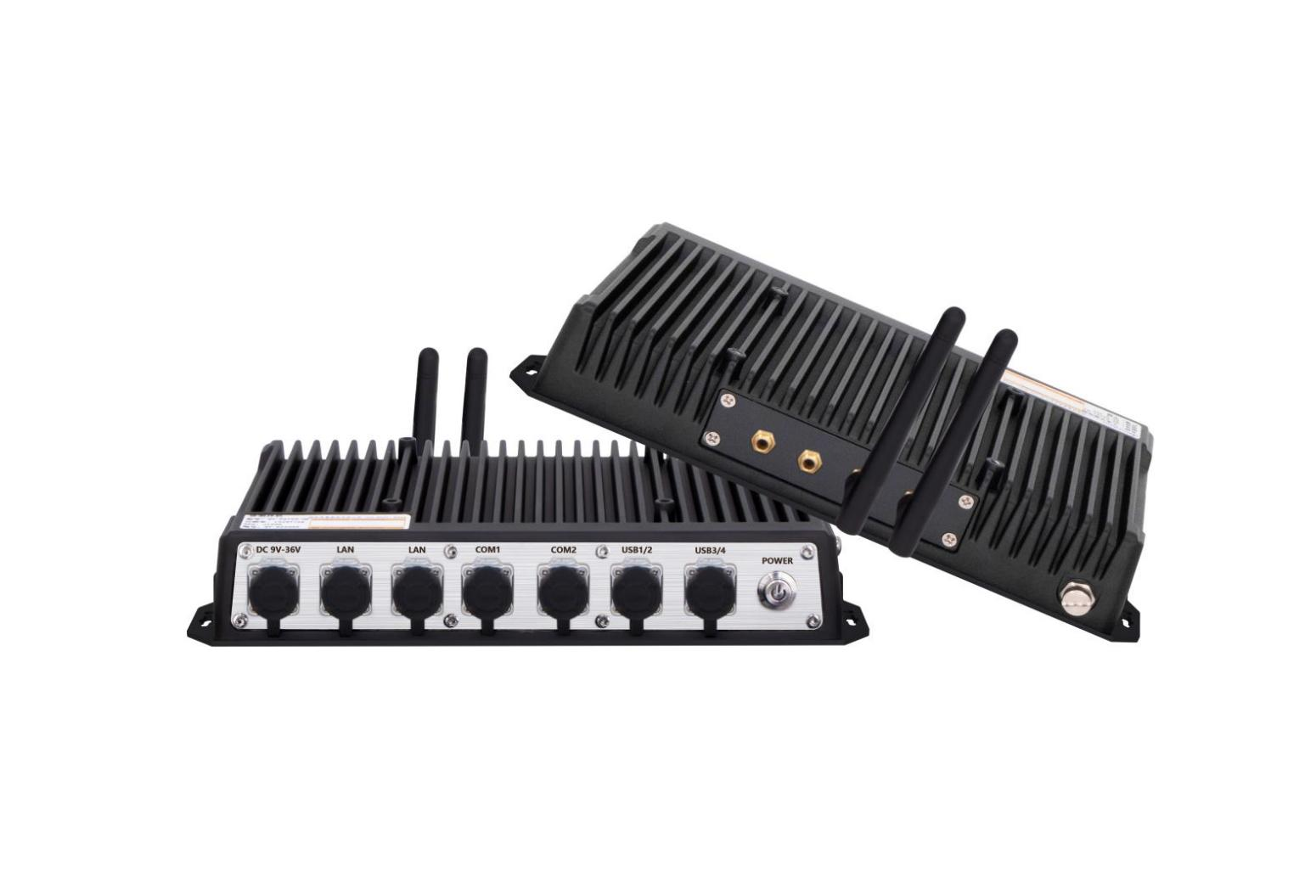

Products Features:
- Industrial-Grade Embedded Fanless Mini PC
- Intel Celeron and Core 4/7/8/10th- i5 / i7 CPU
- 2*LAN, 4*USB, 6*COM, 1*VGA, 8*GPIO
- 1*Mini PCIE+1*M.2 Expansion Slots, Support 4G/5G and WIFI Module
- DC 9-36V Power Input With Overvoltage Protection
- -30℃~70℃ Temperature Can Keep 24/7 Work Stably
- Anti-Static, Anti-Pulse, Anti-Surge, Anti-Radiation
- Full IP66 Water Proof Protection
QY-B5400
1.Mother Board Specification:
Model | QY-B5400
CPU | J1900  i5-4260U | J6412  i5-7200U / 8260U / 10210U  i7-7500U / 10710U
Memory | 1*DDR III RAM Slot, Up to 8GB | 1*DDR IIII RAM Slot, Up to 16GB
Storage | 1*MSATA SSD Slot
Display^{[1]} | 1*VGA: Resolution up to 1920*1200@60Hz
Expansion | 1*Mini PCIE Slot+1*M.2 Slot, Support 4G/5G and WIFI module
Ethernet^{[2]} | 2*Intel i210V LAN Chip (10 / 100 / 1000 Mbps, M12 Type)
USB^{[3]} | 4*USB 2.0 (M12)
COM^{[4]} | 2*RS-232 / 422 / 485 (M12 Type)  4*RS-232 (M12 Type)
GPIO^{[5]} | 8 ports GPIO (4*GPI+4*GPO, M12 Type, optional)
Notes:
[1][2][3][4][5]: All ports will be welded to M12 type: 1*VGA port=1*M12 port, 1*Ethernet port=1*M12 port, 2*USB ports=1*M12 port, 2*COM ports=1*M12 port

Default configuration: 1*Power supply port+2*Ethernet ports+4*USB ports+1*RS-485+1*RS-232 ports+1*VGA port (Total 7*M12 ports), Please inform the sales person of the specific specifications you require if you require interfaces beyond the default configuration.

2.Device Specification:
QY-B5400
Watch Dog | Support
Power Input | DC 9-36V With Overvoltage Protection
Power Input | Support Auto-Start
Power Input | M12 Type DC Plug
Working Temperature | -30℃~70℃, Support 24/7 Working
Structure | Fully Enclosed Aluminum Alloy Material
Heat Dissipation | Fanless Design, Conduction Heat Dissipation
Installation | Desktop / Embedded / Wall Mount
Size | 260mm*152mm*43mm
System | Windows and Linux
Protection | Full IP66 Water Proof (EN60529:1991+A1:2000+A2:2013)

QY-B5400
3.Ordering Information:
Model | CPU | LAN | USB | COM | Display | RAM | SSD | Expansion | Power
QY-B5400 | J1900 / 4th | 2 | 4 | 2*RS-232/422/485  4*RS-232 | 1*VGA | 1*DDR 3  Up to 8GB | 1*MSATA | 1*Mini PCIE  1*M.2 | DC 9-36V
QY-B5400 | J6412 / 6th / 7th |  |  |  |  | 1*DDR 4  Up to 16GB | 1*MSATA | 1*Mini PCIE  1*M.2 | DC 9-36V
QY-B5400 | 8th / 10th |  |  |  |  | 1*DDR 4  Up to 32GB | 1*MSATA | 1*Mini PCIE  1*M.2 | DC 9-36V

4.CPU Information:

CPU | Specification
J1900 | 4 core, 4 total threads, 2.00 GHz to 2.42GHz, 2 MB cache | Max to 8GB for 1*RAM 3 slot
i5-4260U | 4 core, 4 total threads, 1.40 GHz to 2.70GHz, 3 MB cache | Max to 8GB for 1*RAM 3 slot
i5-6200U | 2 core, 4 total threads, 2.30 GHz to 2.80GHz, 3 MB cache | Max to 16GB for 1*RAM 4 slot
i5-7200U | 2 core, 4 total threads, 2.50 GHz to 3.10 GHz, 3 MB cache | Max to 16GB for 1*RAM 4 slot
i7-7500U | 2 core, 4 total threads, 2.70 GHz to 3.50 GHz, 4 MB cache | Max to 16GB for 1*RAM 4 slot
i5-8260U | 4 core, 8 total threads, 1.60 GHz to 3.90 GHz, 6 MB cache | Max to 32GB for 1*RAM 4 slot
i5-10210U | 4 core, 8 total threads, 1.60 GHz to 4.20 GHz, 6 MB cache | Max to 32GB for 1*RAM 4 slot
i7-10710U | 6 core, 12 total threads, 1.60 GHz to 4.70 GHz, 12MB cache | Max to 32GB for 1*RAM 4 slot

QY-B5400
5.System Information:

CPU | System
J1900 | Windows 7 / 10 and Linux
4th / 6th / 7th | Windows 7 / 10 and Linux
J6412 | Windows 10 / 11 and Linux
8th / 10th | Windows 10 / 11 and Linux
RAM | DDR 3 | 4GB / 8GB
RAM | DDR 4 | 4GB / 8GB / 16GB / 32GB
Storage | MSATA | 64GB / 128GB / 256GB / 512GB / 1TB
GSM Module | 4G | 4G+GPS
GSM Module | 5G | 5G+GPS
WIFI Module | 7260AN / 7260AC / AX210
CAN BUS Module | 2*CAN BUS interfaces
6.Fittings Information:

7.Package List:
Adapter | 1*12V 5A Adapter
Power Cable | 1*Power Cable
M12 Cable-1 | M12 port cable for Ethernet
M12 Cable-2 | M12 port cable for Ethernet
M12 Cable-3 | M12 port cable for USB
M12 Cable-4 | M12 port cable for USB
M12 Cable-5 | M12 port cable for VGA
M12 cable-6 | M12 port cable for COM
QY-B5400

8.Dimensions:

